NUMBER LINE
KS1 – 2003 Paper 2
1.
KS1 – 2004 Paper 1
2.
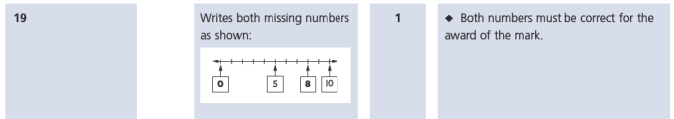
KS1 – 2004 Paper 2
3.
KS1 – 2005 Paper 1
4.
KS1 – 2005 Paper 2
5.
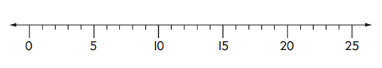
KS1 – 2007 Paper 1
6.
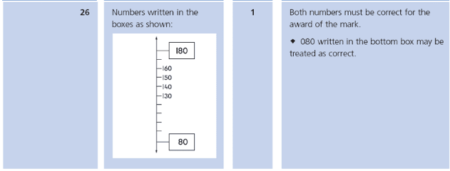
KS1 – 2007 Paper 2
7.
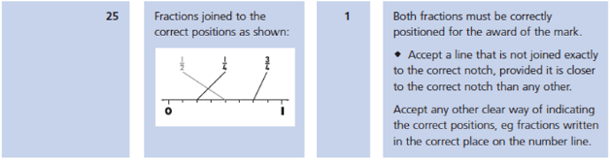
KS1 – 2016 Paper - Reasoning
8.
KS1 – 2016 Paper – Reasoning (Second)
9.
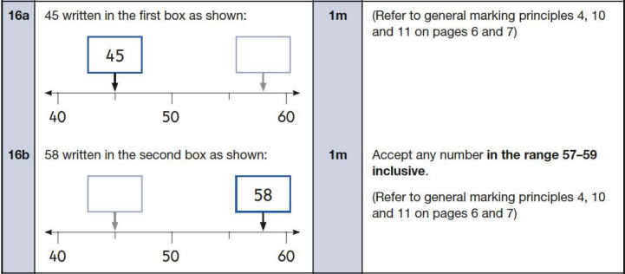
KS1 – 2017 Paper – Reasoning
10.
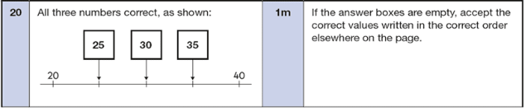

KS1 – 2018 Paper – Reasoning
11.
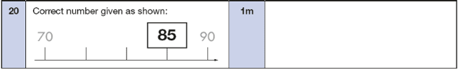
KS1 – 2019 Paper – Reasoning
12.
